**EXPERIMENT 4**

**Aim: To use github+Jenkins+maven to automate a build in any maven project (CI)**

**Create a maven project with any simple code in it**

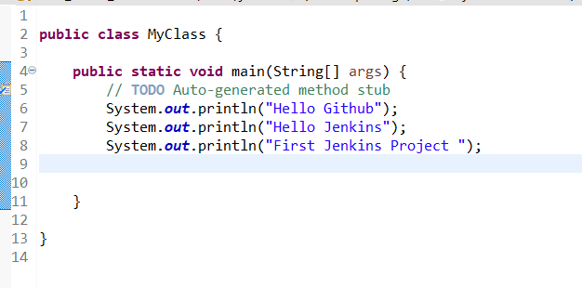

**Start jenkins in command prompt**

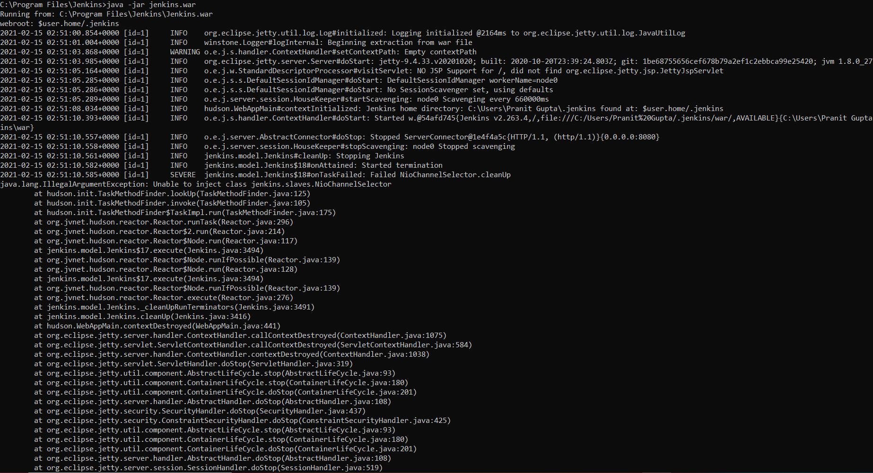

**Create a github repo for recording changes**

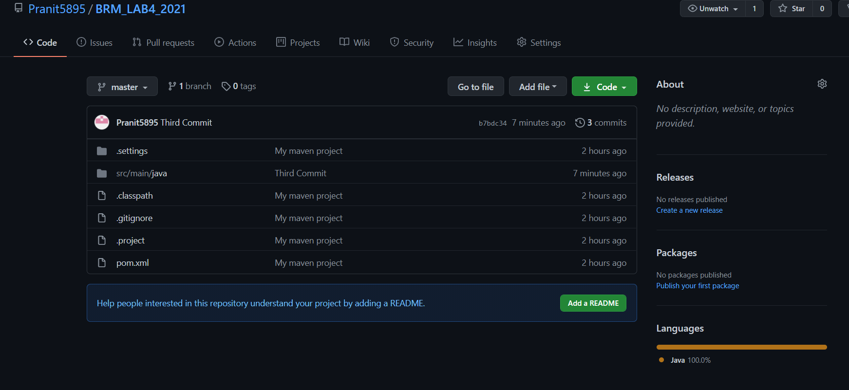

**After this share the above maven project with git repositories**

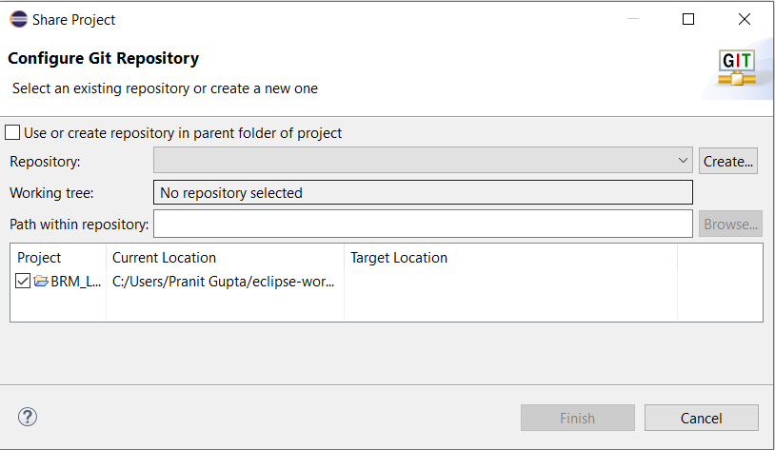

**Add the above made github repo to eclipse**

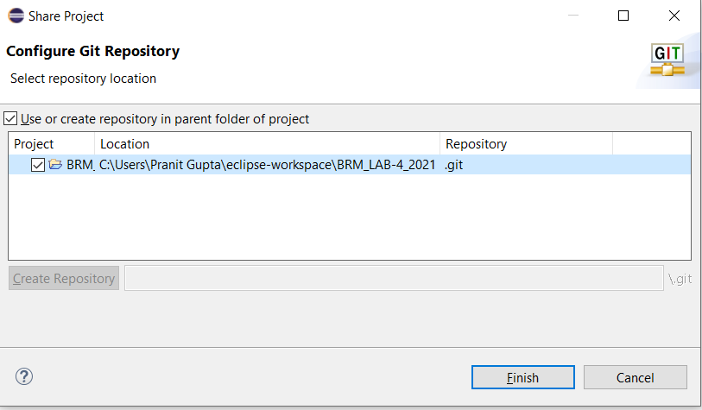

**After this stage the unstaged changes**

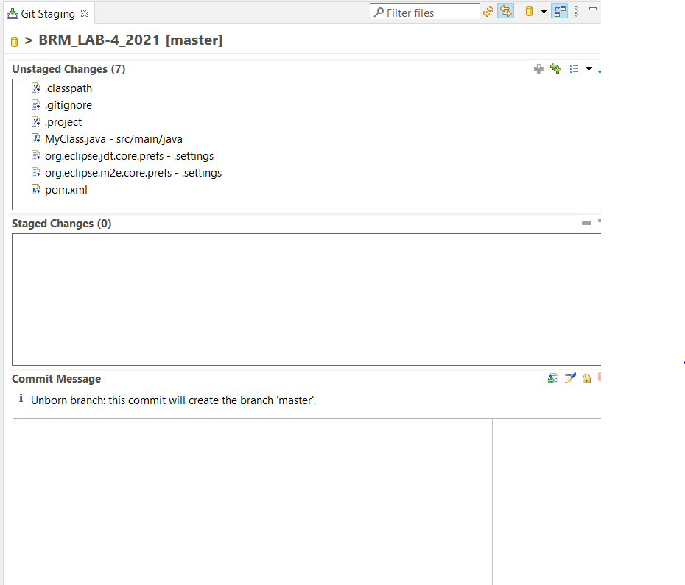

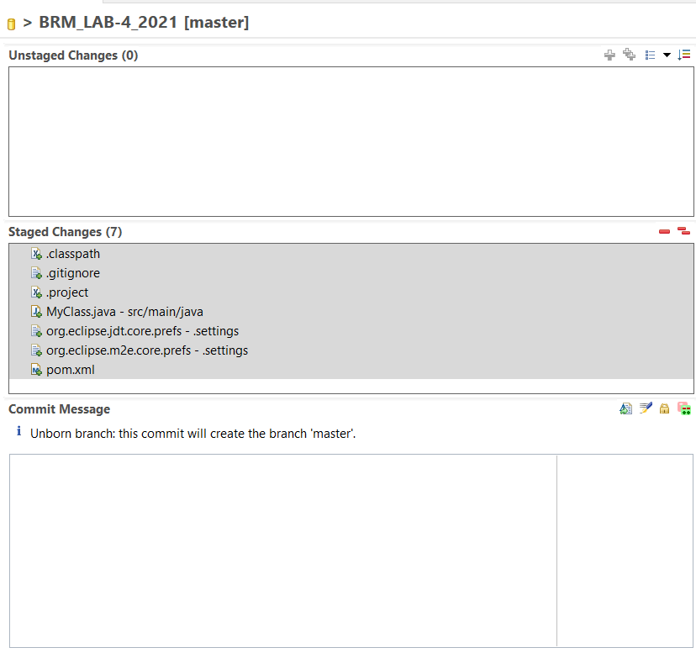

**Commit changes**

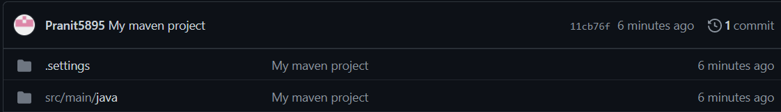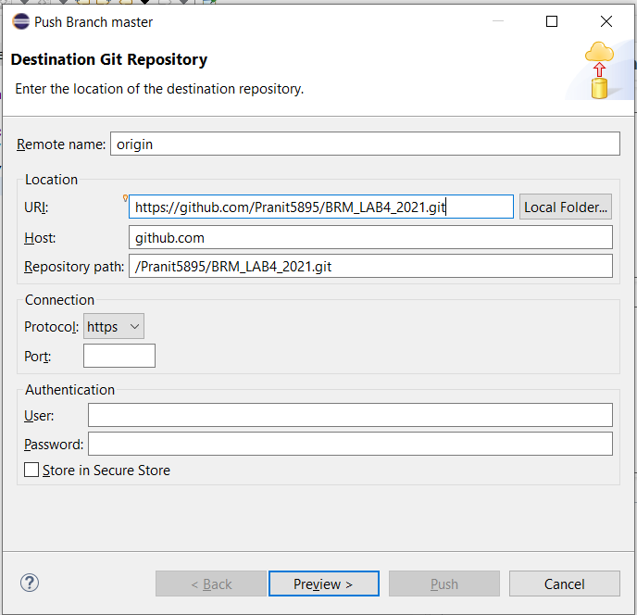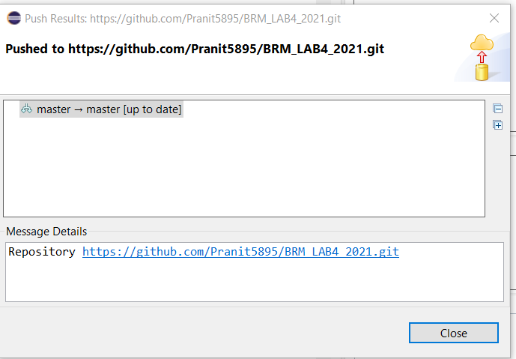

**After this login to Jenkins dashboard and make a maven project in Jenkins. And then start the build using build now option**

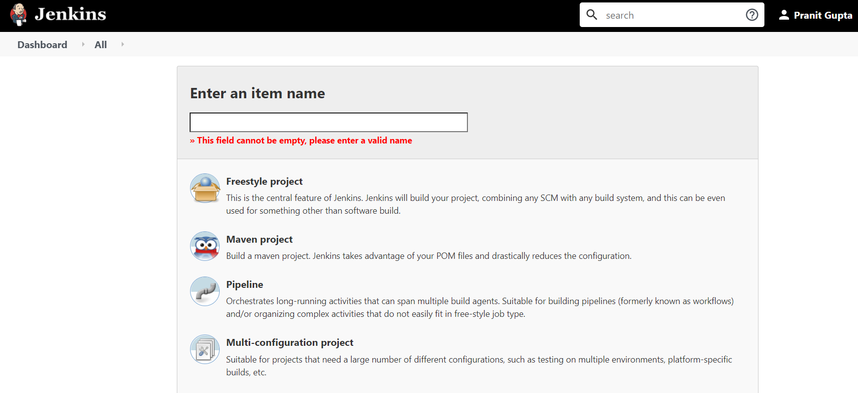

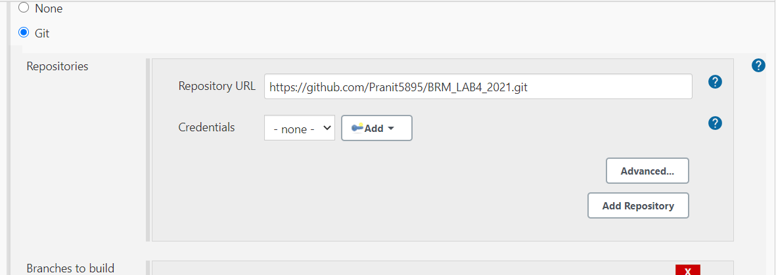

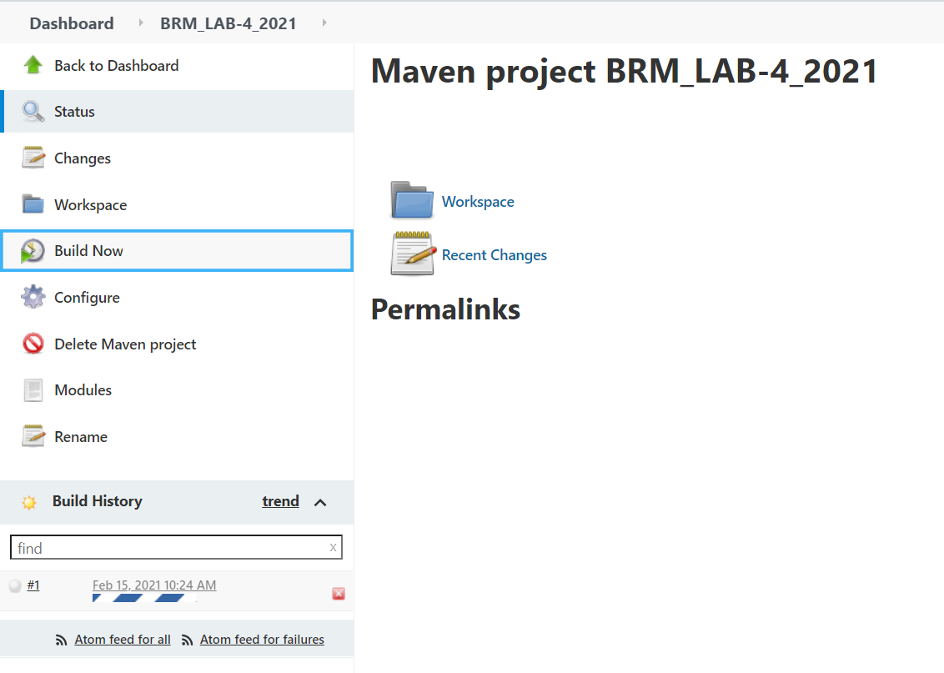

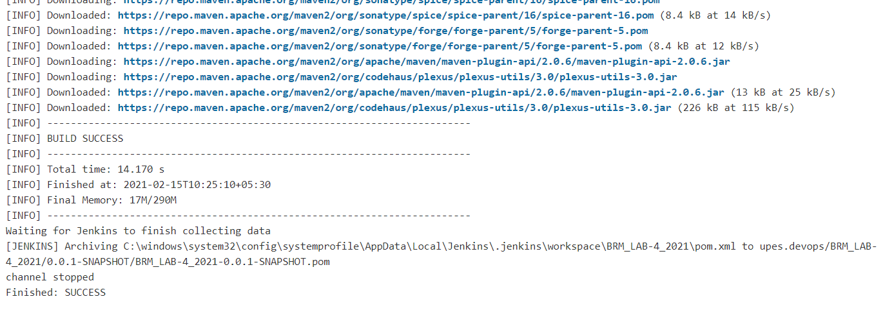

**After this we use Poll SCM to automate our job that is Continuous Integration and change the setting to every one minute due to which any change we commit to git repo will automatically start build in Jenkins within 1-2 mins.**

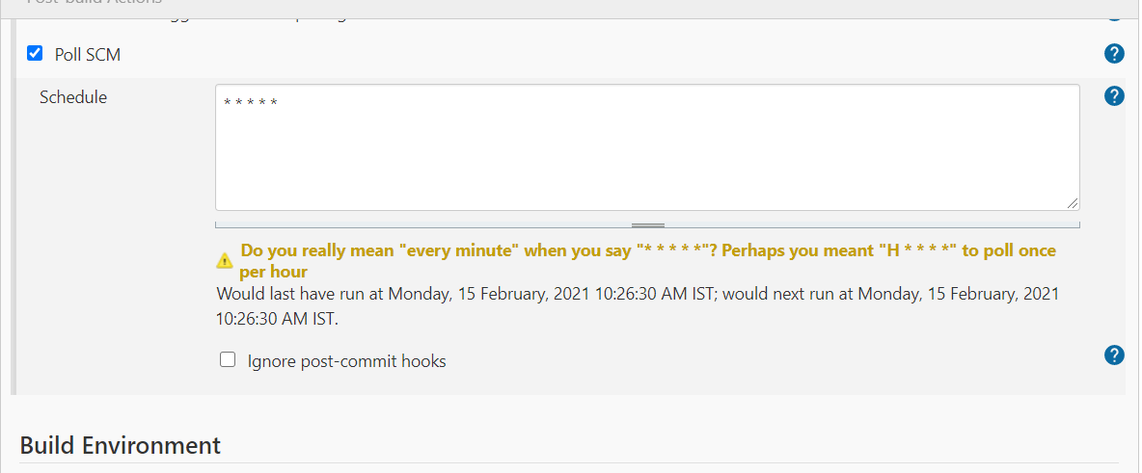

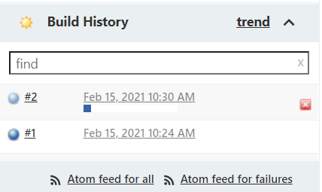

**Hence both build have been made and were successful.**

